Web App Development Project

|  |  |
| --- | --- |
| **Group Name** | |
| Group 19 | |
| **Student Name** | **GitHub Account** |
| Keith Driscoll | <https://github.com/Keith-Driscoll/Profile-System> |
| **Link to your final Workspace in Cloud9** | |
| <http://ggleagues.com/x14346081> | |
| **Node.js modules used in the project (if applicable)** | |
| n/a | |

Project proposal

My project idea was to develop a functional player profile system for my personal project which has been ongoing since June 2015, ggleagues.com. My profile system is being designed to allow users to login to their accounts, access their profile page and edit information about themselves. Information of every player will be stored on the MySQL database via PHP.  
  
The main goals of this project is to allow user registration and login. To create a grid-like interface for the profile page which is responsive, allowing players to view and manage their profiles across multiple devices.

The login and registration system will mainly be developed using PHP and HTML. HTML forms will be used to get players to enter their desired details, PHP will be used to retrieve that information and save them to the MySQL database.

The grid-like interface for the profile page design was styled using CSS and was made possible using the Bootstrap framework enabling my design to become responsive cross-platform.

The key characteristics of my project in terms of functionality would be the Login feature and having the profile page display information depending on which player account you are logged in as.

Overview of Technologies

HTML and CSS were used to create the layout and the styling of my web application using the Bootstrap Framework for webpage responsiveness.

**HTML5** – Hyper text mark-up language which is the web’s core language used for creating documents and applications for everyone to use anywhere.

**CSS3** – cascading style sheets is used for describing the presentation of a document written in html or xhtml. CSS is what allows websites to look more than just lists of links and

paragraphs of texts on one page which was the norm when the internet first began.

**Bootstrap** – is a framework which makes front-end web development faster and easier, containing libraries of html, css and javascript.

**XHTML** – eXtensible hypertext markup language is a stricter version of HTML which requires documents to be well-formed. It’s a combination of the strengths between HTML and XML.

**XML** – eXtensible mark-up language is like HTML but the main difference is, you define your own tags; HTML has pre-defined tags you must use. I used XML to create well-formed documents containing information required.

**XSLT** – eXtensible stylesheet language transformations allows your to transform your XML document into HTML. The original document is not changed, a new document is created based on content of the existing one.

**Javascript** – is a high-level, interpreted programming language. Which was used to add extra functionality to my web application that was not possible with HTML and/or CSS

**AJAX** – is short for asynchronous javascript and xml which is used on the client-side to create asynchronous web applications.

**PHP** – is a server-side scripting language designed for web development. Used to turn my Static webpage into a dynamic webpage.

**jQuery** – is a fast, small and feature-rich javascript library. This was used for Dropdown links, fadeIn/fadeout effects and for Bootstrap’s framework.

Architecture

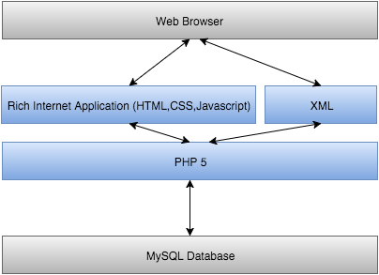

Information is loaded to the user’s web browser. Information is also sent from the web browser to the MySQL Database. The main webpage consists of HTML,CSS,Javascript which also saves separate XML files. These files are connected to the MySQL Database through PHP, which is a client-side scripting language.

Manual

**Main page and information you see will be stored on a database and display depending on which user you’re are logged in as.**

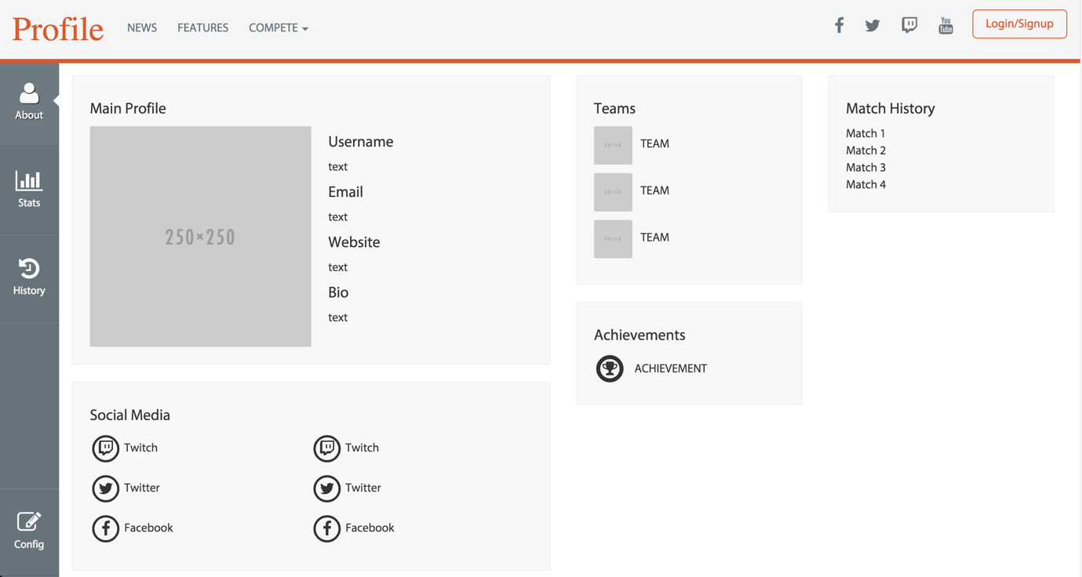

**Working Login System with form validation**

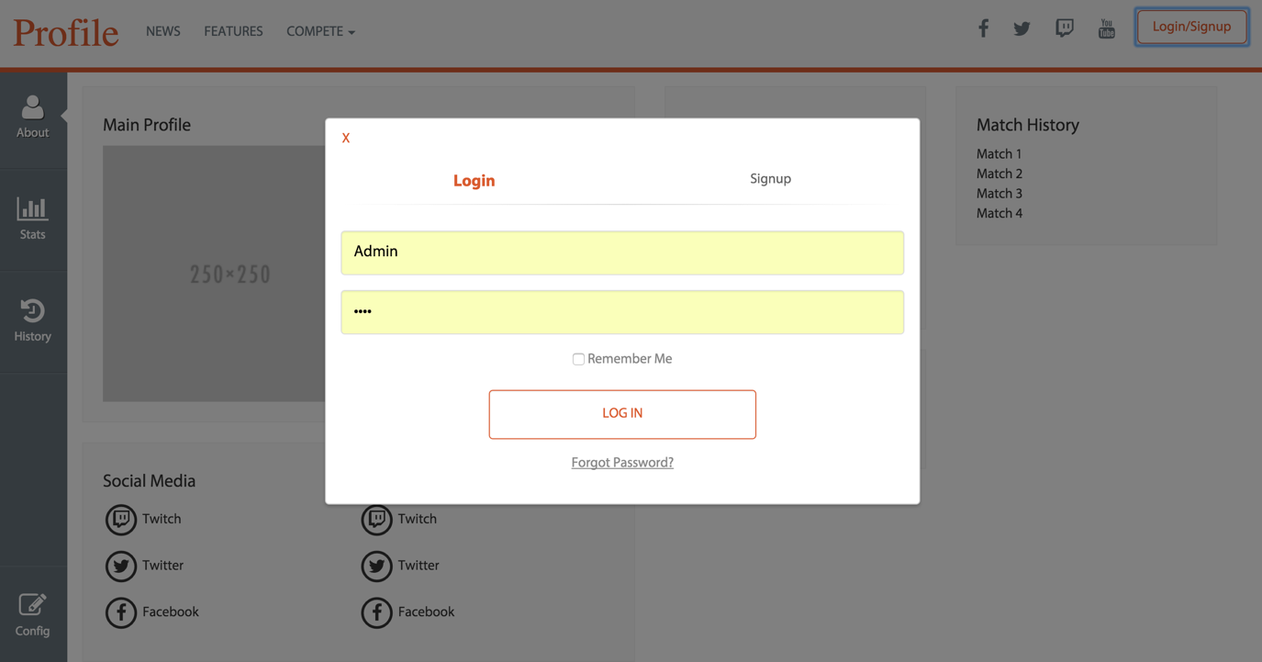

**When logged in username appear in the navigation bar**

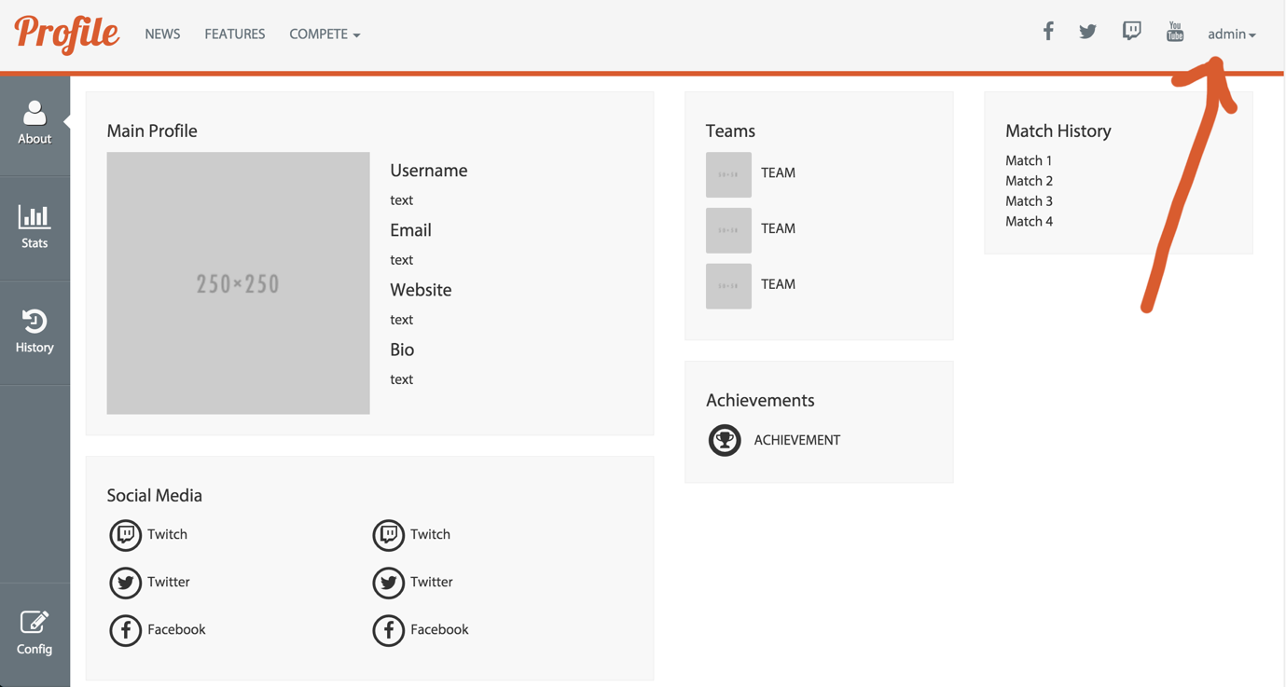

**Config button will allow information on user’s profile to become editable using html’s ‘content-editable- attribute. When editing is complete, the users new update will be stored on the database via php.**

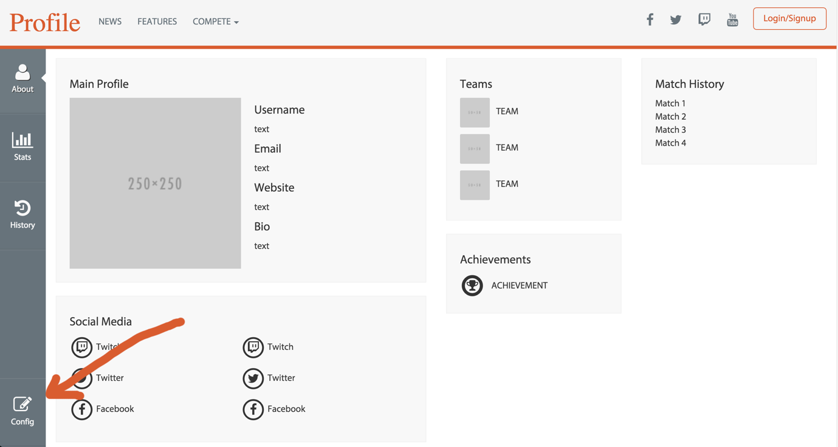

**The Stats tab will contain statistics on the user, displayed in graph form. Stats will be stored in XML which will be saved on the database via PHP. (Stats in the screenshot were taken from:** [**https://d13yacurqjgara.cloudfront.net/users/65795/screenshots/1053366/2.jpg**](https://d13yacurqjgara.cloudfront.net/users/65795/screenshots/1053366/2.jpg) **for demonstration purposes only).**

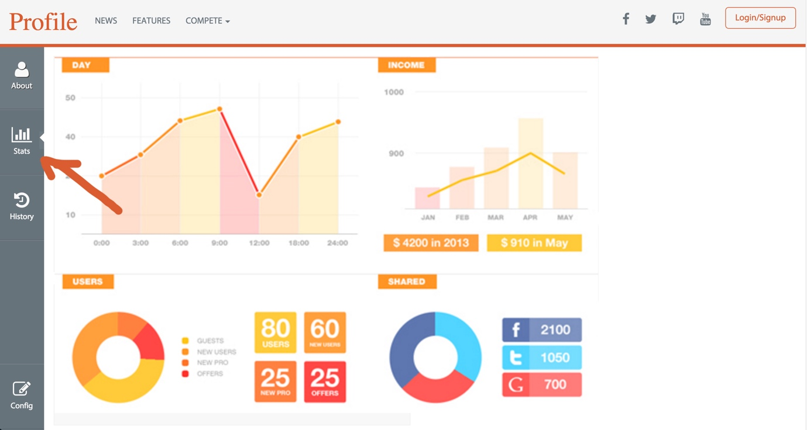

**This is all responsive too of course! Thanks to Bootstrap’s grid framework.**

